Govt. High School
Sindhi Jamaat Co-Operative Housing Society, Karachi
Final Term Examination 2024-25
Subject: Maths | Class: Three | Total Marks: 100
Name: ___________________ |  | Sign: ____________________
GR No: ___________________ | Date: ____________ | Obtained Marks: _________

Section “A”
Q1. Multiple choice Questions. (5)
1- A shape with three sides is called a:
a) Square | b) Triangle | c) Rectangle
2- how many minutes are there in an hour?
a) 60 | b) 10 | c) 90
3- Basic unit of length is:
a) meter | b) litre | c) grams
4- 1000 grams=
a) 1kg | b) 1 litre | c) 1 meter
5- what fraction of the shape is shaded?
a) 1/2 | b) 1/3 | c)1/4

2- Fill in the blanks. (5)
- A clock has ______________ hands.
- A rectangle has ____________ vertices.
- A circle looks like a___________.
- The long hand of the clock shows__________
- 140cm is equal to___________
3- True or false. (5)
- A fraction is equal parts of the whole. ______
- A square has three sides. ________
- 100 minutes= 1 hour____
- A circle has no sides_____
- 100cm = 1km_______
4- Match the following. (5)
Column A | Column B
60 | Square
1/4 | 1 hour
4sides, equal length | Noon
3sides | Quarter
12:00 pm | Triangle

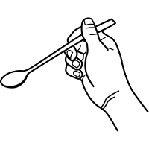
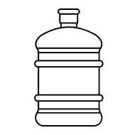

Q5: color the suitable unit of capacity for the given. (3)
L
ML
L
ML
L
ML

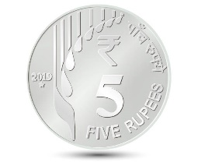

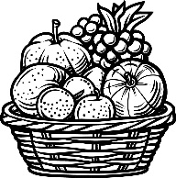
Q6: Write the correct unit of mass with (kg or g). (3)

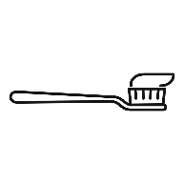
Q7: Object measured in (cm,m,km). (3)
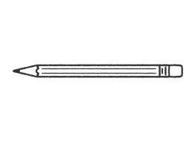
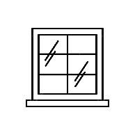

Q8: Color ¼ of given shapes (3)

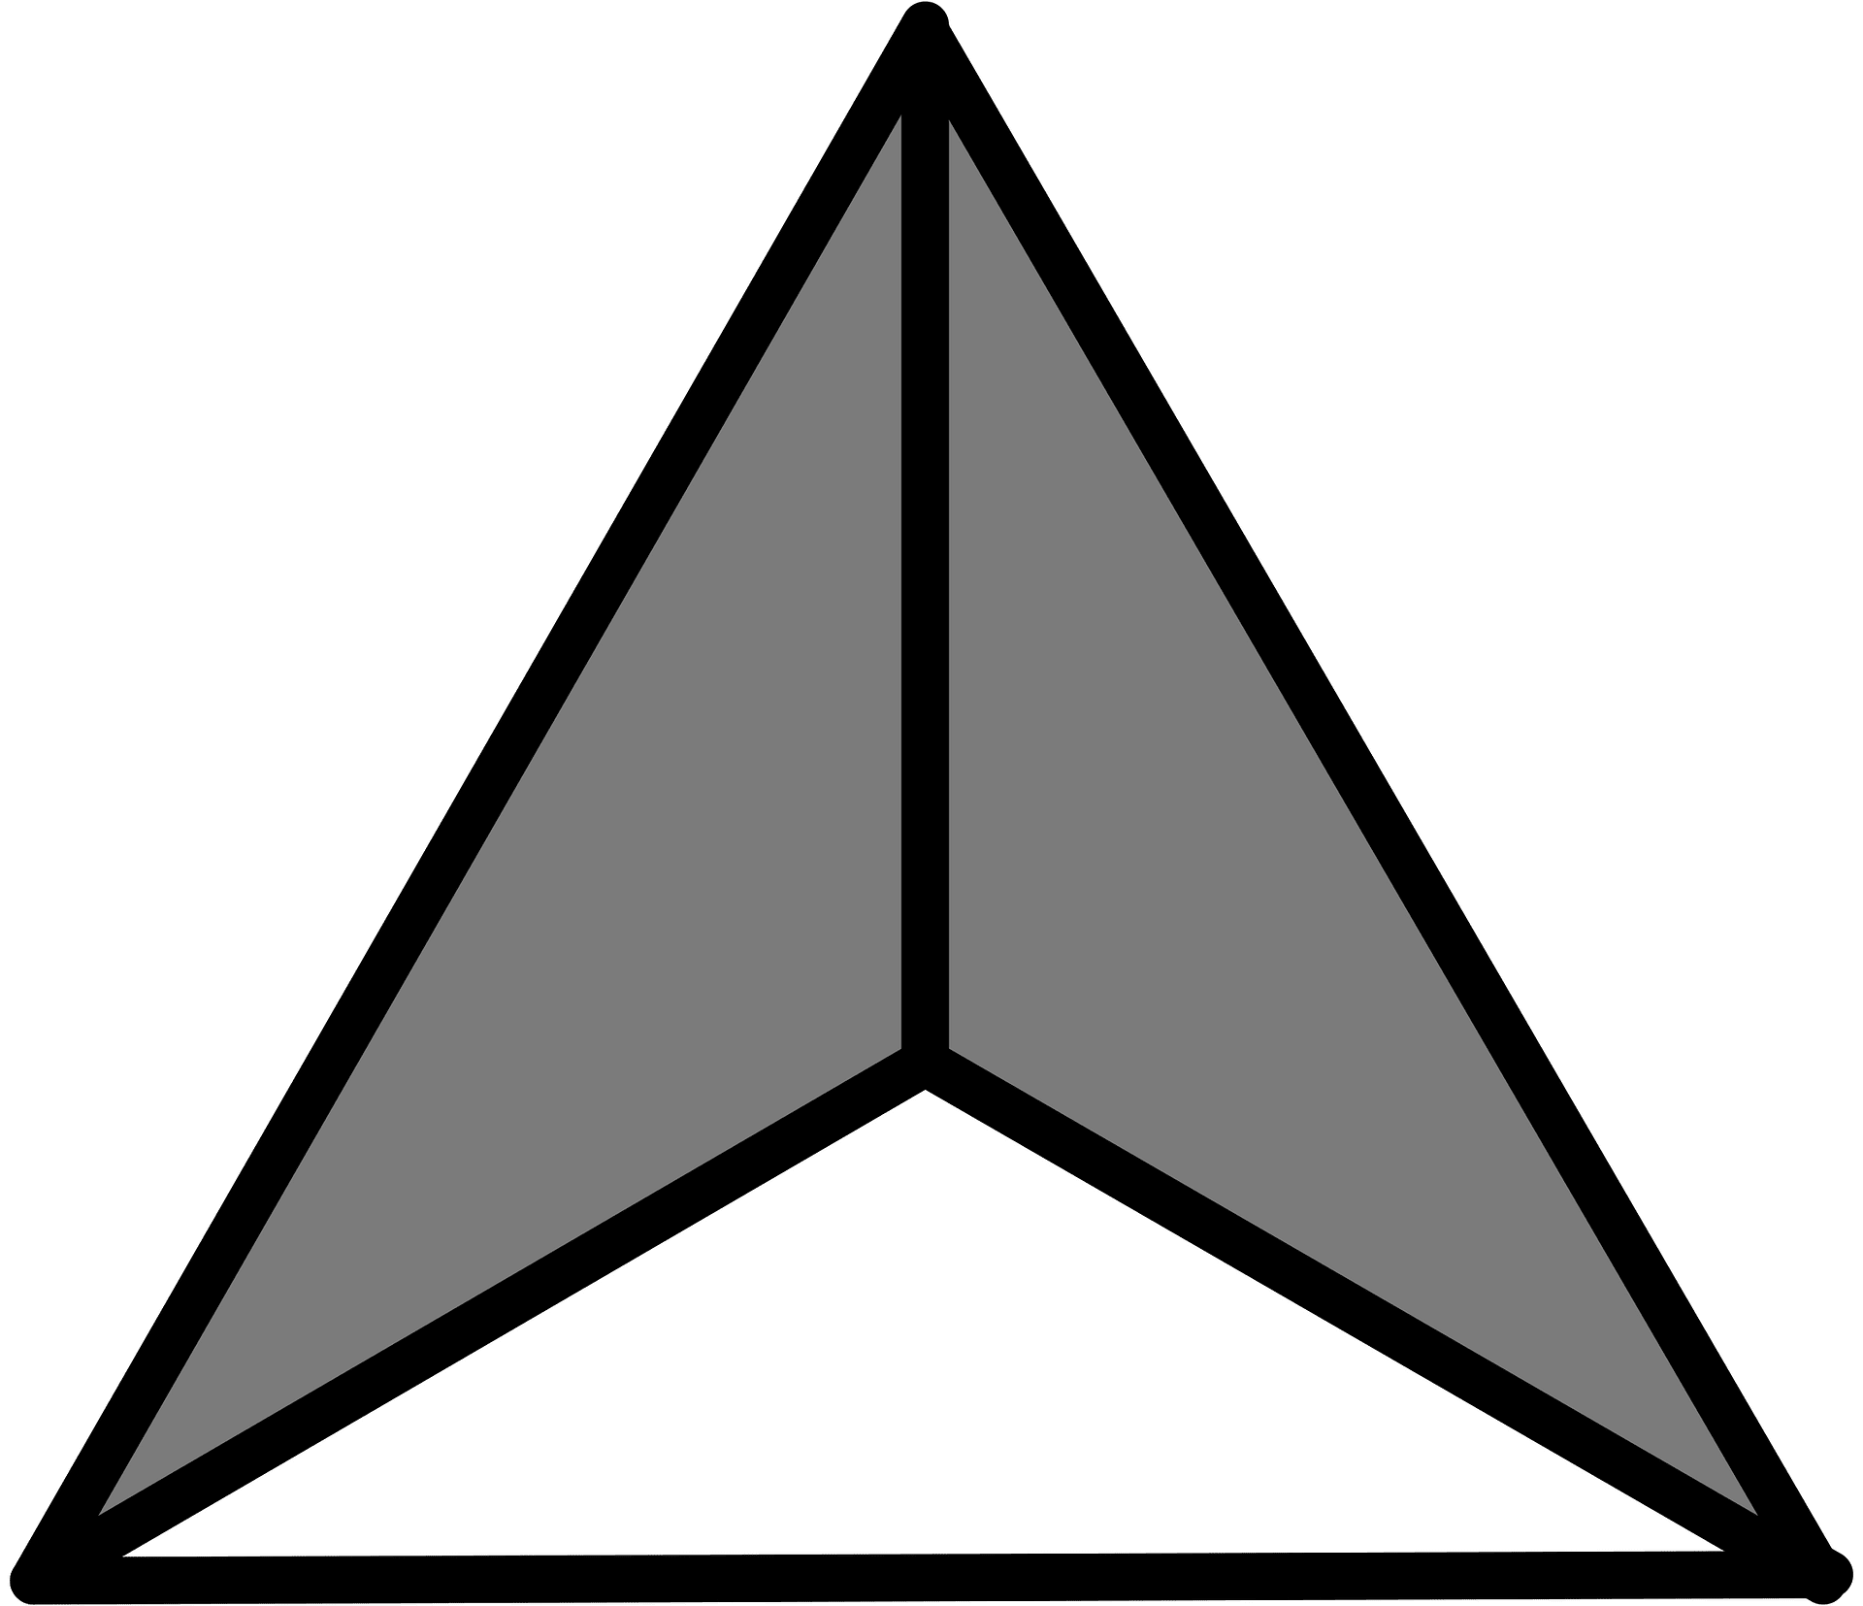
Q9: Express the fractions of colored parts of the given figures numerically. (3)

Q10: Write the time. (3)
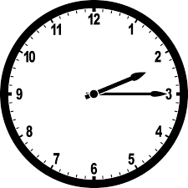
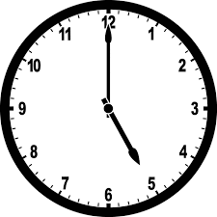
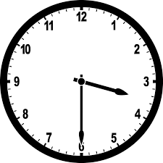

Section “B”
Q10: Write proper and improper fractions in the following boxes. (6)
$$\frac{2}{9} , \frac{4}{3} , \frac{11}{7} , \frac{6}{1} , \frac{1}{3} , \frac{2}{5}$$
Proper fraction | Improper fraction

Q11: Solve the following fractions. (4)
- $\frac{1}{3} + \frac{1}{3} = \frac{}{}$ 2) $\frac{5}{9} + \frac{4}{9} = \frac{}{}$
(i) Solve: (6)
 | 2 | 3 | 9 | 6 | km |  |  | 3 | 5 | m |  |  | 3 | 5 | 0 | g
+ | 5 | 7 | 2 | 5 | km |  | + | 4 | 6 | m |  | + | 1 | 5 | 0 | G

(ii) Subtract: (6)
- $\frac{1}{4} from \frac{2}{4} = \frac{}{}$ 2) $\frac{8}{9} - \frac{1}{9} = \frac{}{} 3) \frac{11}{17} - \frac{8}{17} = \frac{}{}$
(i) Word Problems: (5)
Aslam Bought 250g of black pepper and 350g red pepper for his kitchen. Find the total weight of both spices.
Solution:

(iI) Word Problems: (5)
Height of Azhar is 1m 22cm and height of his father is 2m 50cm. How much his father taller than him?
Solution:

Section “C”
Q12: Geometry (10)
Draw a square and a triangle and label their sides.

Q12: Find the perimeter of following figures. (10)
Z | 6cm | Y | Line segment ZY =__________cm
 |  |  | Line segment YX =__________cm
3m |  | 3m | Line segment XW =__________cm
 |  |  | Line segment WZ =__________cm
W | 6cm | X | Perimeter = __________cm
D
E
F
Line segment EF =__________cm
Line segment FD =__________cm
Line segment DE =__________cm
Perimeter = __________cm

